**Assignment 10.3**

***INPUT:***

: 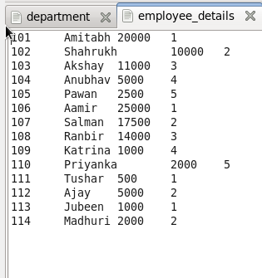  
  
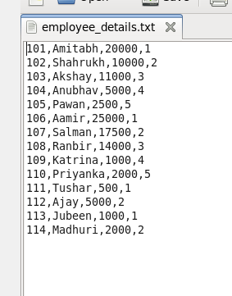

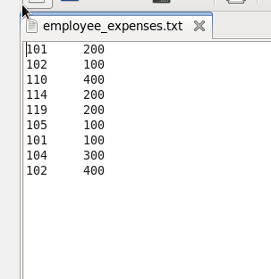

**Question:** Top 5 employees (employee id and employee name) with highest rating. (In case two employees have same rating, employee with name coming first in dictionary should get preference).

***Code:***

*A = load ‘employee_details.txt’ using PigStorage(‘,’) as (emp_id:int,emp_name:chararray,emp_salary:int,emp_rating:int);*

*ordered_A = order A by emp_rating desc,emp_name;*

*top5 = limit ordered_A 5;*

*dump top5;*

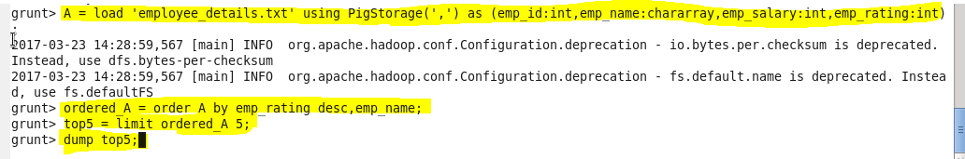

***OUTPUT:***

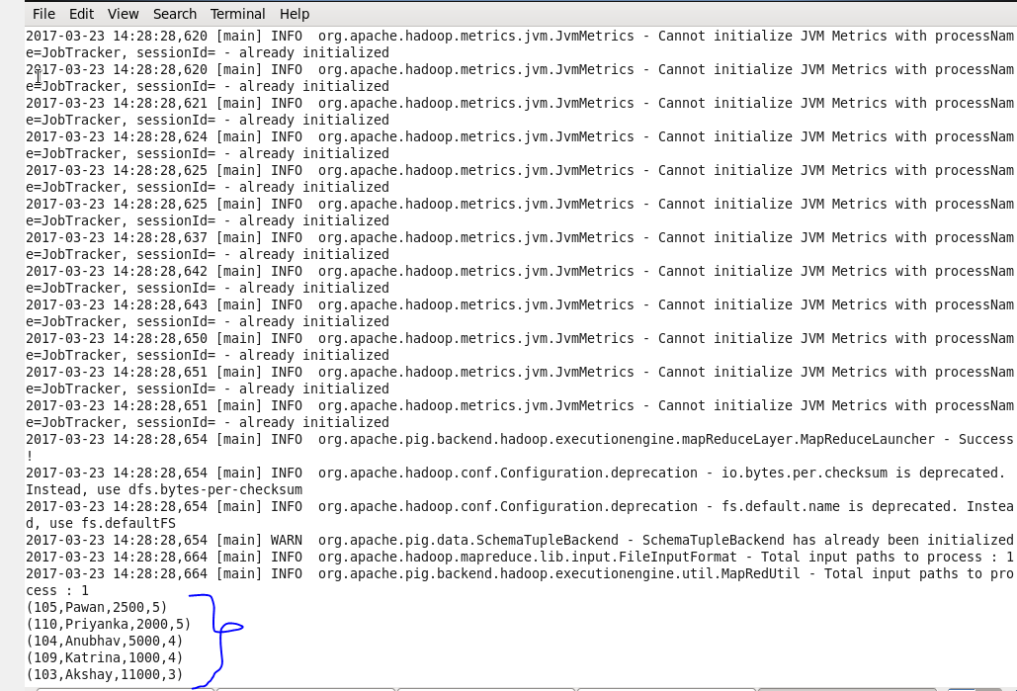

**Question:** Top 3 employees (employee id and employee name) with highest salary, whose employee id is an odd number. (In case two employees have same salary, employee with name coming first in dictionary should get preference).

***Code:***

Emp2 = load ‘employee_details.txt’ using PigStorage(‘,’) as (emp_id:int,emp_name:chararray,emp_salary:int);

Ordered_emp2 =order emp2 by emp_salary desc,emp_name;

Filtered_emp2 = FILTER ordered_emp2 by emp_id%2!=0;

Dump filtered_emp2;

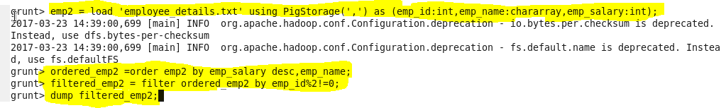

**OUTPUT:**

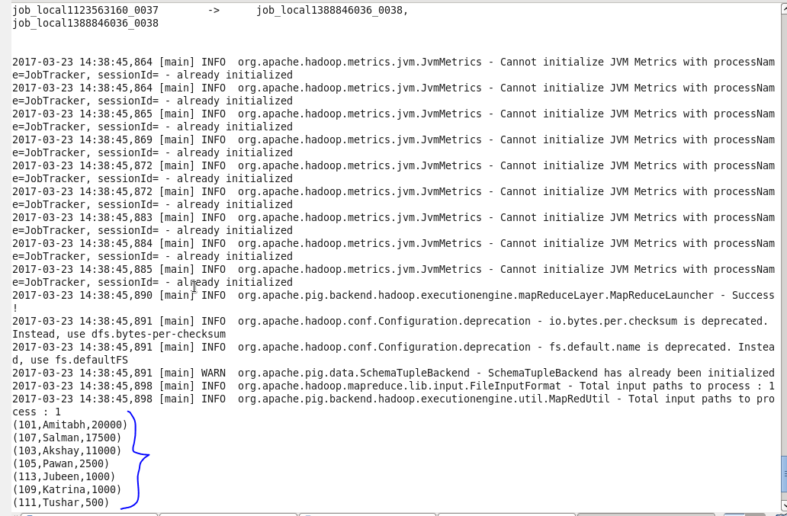

**Question:** Employee (employee id and employee name) with maximum expense (In case two employees have same expense, employee with name coming first in dictionary should get preference.

***Code:***

A = load ‘employee_details’ using PigStorage(‘\t’) as (emp_id:int,emp_name:chararray);

join_AB = join A by emp_id,B by emp_id;

group_AB = group join_AB by A::emp_id;

sum_AB = FOREACH group_AB generate group,(join_AB.name)as name,SUM(join_AB.expenses) as expenses;

flt = FOREACH sum_AB generate group as id,FLATTEN(name) as name,expenses;

a =DISTNICT flt;

order_a = order a by expenses;

max = limit order_a 1;

dump max;

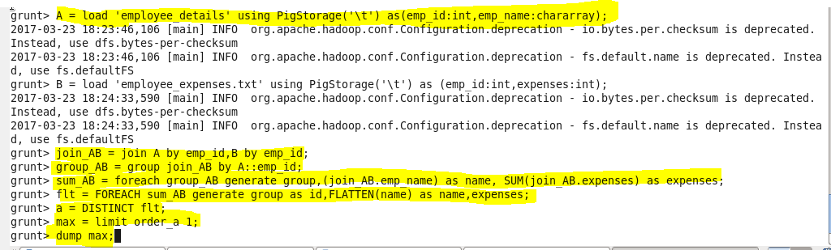

**OUTPUT:**

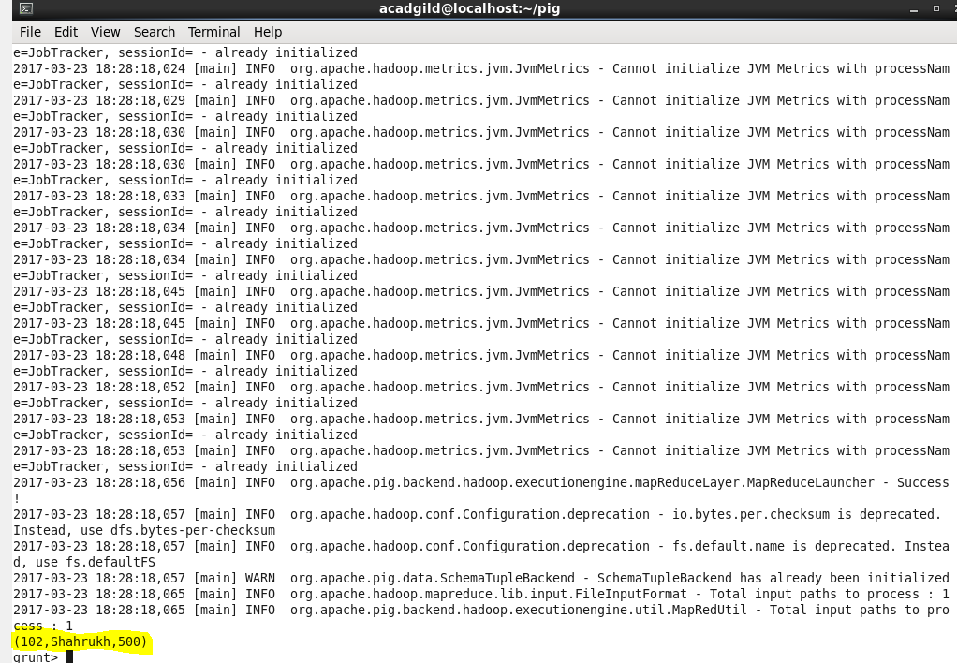

**Question:** List of employees (employee id and employee name) having entries in employee_expenses file.

***Code:***

A = load ‘employee_details’ using PigStorage(‘\t’) as (emp_id:int,emp_name:chararray);

B = load ‘employee_expenses.txt’ using PigStorage(‘\t’) as (emp_id:int);

joinAB = join A by emp_id, B by emp_id;

distAB = DISTINCT joinAB;

D = FOREACH distAB generate $0,$1;

Dump D;

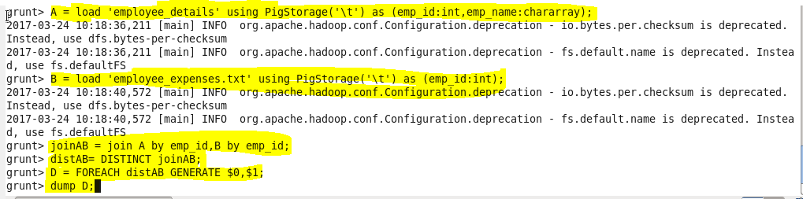

**OUTPUT:**

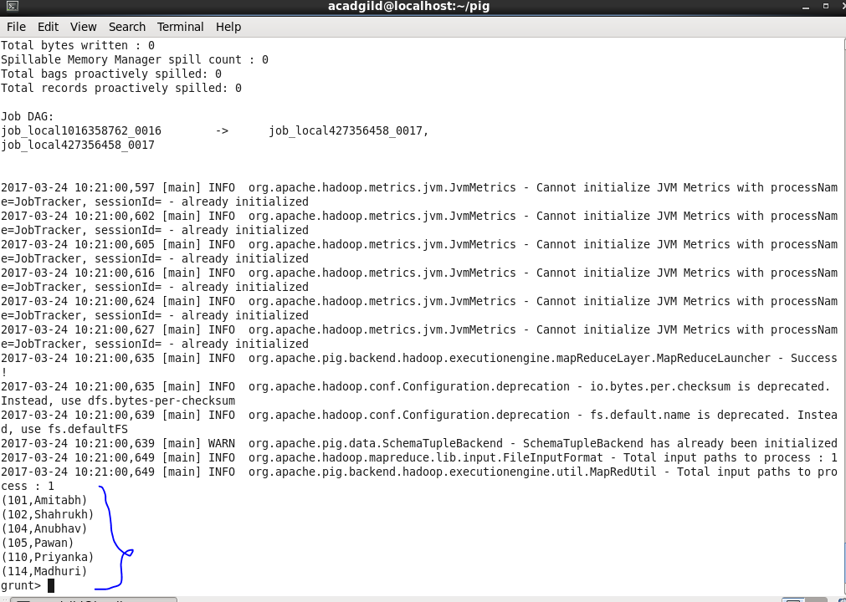

**Question:** List of employees (employee id and employee name) having no entry in employee_expenses file

***Code:***

A = load ‘employee_details’ using PigStorage(‘\t’) as (emp_id:int,emp_name:chararray);

B = load ‘employee_expenses.txt’ using PigStorage(‘\t’) as (emp_id:int);

joinAB = join A by emp_id left outer, B by emp_id;

filterAB = FILTER joinAB by $2 is null;

e = FOREACH filterAB generate $0,$1;

dump e;

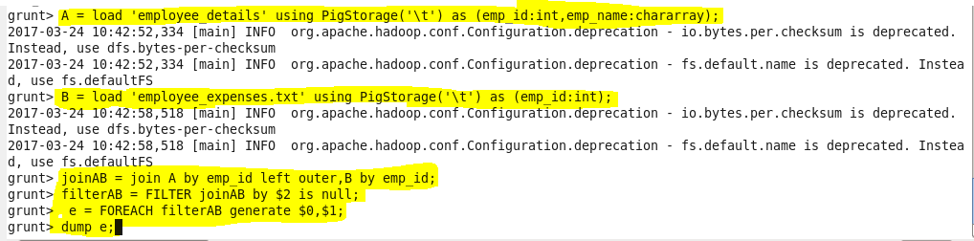

**OUTPUT:**

